Social media posts
Theme | Copy | Asset | Welsh copy
Booklet  Messages  (ONLY USE THIS ONE THIS WEEK, AS LEAFLETS DUE TO BE DELIVERED NEXT WEEK) | Next week, South Powys residents will have an information booklet delivered through their doors about #NevillHallChanges.  You can read it online here too: pthb.nhs.wales/nevill-hall. | NH changes animation or  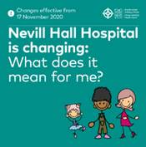 | Yr wythnos nesaf, bydd llyfryn gwybodaeth yn cyrraedd trwy flwch post trigolion De Powys am #NewidiadauNeuaddNevill.  Gallwch ei ddarllen ar-lein yma hefyd: biap.gig.cymru/neuadd-nevill.
Booklet messages | Nevill Hall Hospital is changing.  We have put together a booklet that contains all the information about #NevillHallChanges  Visit pthb.nhs.wales/nevill-hall to have a read📖. | NH changes animation or  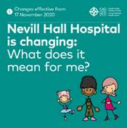 | Mae Ysbyty Neuadd Nevill yn newid.  Rydym wedi llunio llyfryn sy'n cynnwys yr holl wybodaeth am #NewidiadauNeuaddNevill  Ewch i biap.gig.cymru/neuadd-nevill i fwrw golwg arno📖
Booklet messages | What do #NevillHallChanges mean for you?  Find out in our information booklet which you can view here: pthb.nhs.wales/nevill-hall. | 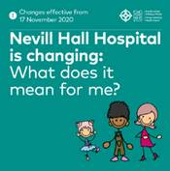 | Beth mae #NewidiadauNeuaddNevill yn ei olygu i chi?  Darganfyddwch yn ein llyfryn gwybodaeth sydd fan hyn: biap.gig.cymru/neuadd-nevill.
Booklet message | Know your healthcare options when Nevill Hall Hospital changes on 17 November 2020:  👉Call 999 or go to A&E if you or your child have a life-threatening illness or serious injury  👉Call 111 or go to MIU if you or your child (aged 2 or over) have a minor injury (children under 2 should be taken to A&E)  To find your nearest A&E or MIU, visit: pthb.nhs.wales/nevill-hall. | 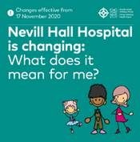 | Gwybod eich opsiynau gofal iechyd pan fydd Ysbyty Neuadd Nevill yn newid ar 17 Tachwedd 2020:  👉Ffoniwch 999 neu ewch i'r adran damweiniau ac achosion brys os oes gennych chi neu'ch plentyn salwch sy'n peryglu bywyd neu anaf difrifol  👉Ffoniwch 111 neu ewch i MIU os oes gennych chi neu'ch plentyn 2 oed neu drosodd fân anaf (ewch â phlant o dan 2 oed i'r Adran Damweiniau ac Achosion Brys)  I ddod o hyd i'ch Adran Damweiniau ac Achosion Brys neu MIU agosaf, ewch i: biap.gig.cymru/neuadd-nevill.
General Nevill Hall changes | Have you heard about the #NevillHallChanges?  To find out what they mean for you and your family, visit pthb.nhs.wales/nevill-hall.  #ClinicalFutures | 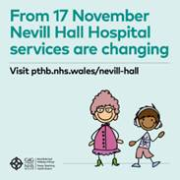 | Ydych chi wedi clywed am y #NewidiadauNeuaddNevill?  I ddarganfod beth maen nhw'n ei olygu i chi a'ch teulu, ewch i biap.gig.cymru/neuadd-nevill.  #DyfodolClinigol
General Nevill Hall changes | Depending on where you live in South Powys the #NevillHallChanges will mean you may be closer to a different hospital for A&E services.  For example, you may now live closer to Prince Charles Hospital in Merthyr Tydfil.  For more information, visit pthb.nhs.wales/nevill-hall. | 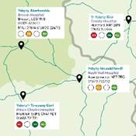 | Yn dibynnu ar ble rydych chi'n byw yn Ne Powys bydd #NewidiadauNeuaddNevill yn golygu efallai eich bod chi'n agosach at ysbyty gwahanol ar gyfer gwasanaethau damweiniau ac achosion brys.  Er enghraifft, efallai eich bod bellach yn byw yn agosach at Ysbyty'r Tywysog Charles ym Merthyr Tudful.  Am ragor o wybodaeth, ewch i biap.gig.cymru/neuadd-nevill.
General Nevill Hall changes | If you want to know more about the #NevillHallChanges coming into place from 17 November 2020, read our FAQs here: pthb.nhs.wales/nevill-hall. | 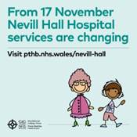 | Os ydych chi eisiau gwybod mwy am y #NewidiadauNeuaddNevill sy'n dod i rym o 17 Tachwedd 2020, darllenwch ein Cwestiynau Cyffredin yma: biap.gig.cymru/neuadd-nevill.
General Nevill Hall changes  Reassurance | We want to reassure you that your health and wellbeing is our priority and you will still get the best treatment, but it might be in a different place.  Read our information booklet here: pthb.nhs.wales/nevill-hall. | 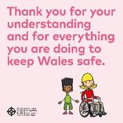 | Rydym am eich sicrhau mai eich iechyd a'ch llesiant yw ein blaenoriaeth ac y byddwch yn parhau i gael y driniaeth orau, ond gallai fod mewn lle gwahanol.  Darllenwch ein llyfryn gwybodaeth yma: biap.gig.cymru/neuadd-nevill.
General Nevill Hall changes  Reassurance | We are sending South Powys residents an information booklet about #NevillHallChanges  Our priority is your health and wellbeing. | NH changes animation | Rydym yn anfon llyfryn gwybodaeth i breswylwyr De Powys am #NewidiadauNeuaddNevil  Eich iechyd a’ch llesiant yw ein blaenoriaeth.
Parents | 📣Parents in South Powys📣  Children services at Nevill Hall Hospital are changing from 17 November.  Take a look at our table to see how👇 | Caring for my child animation | 📣Rhieni yn Ne Powys📣  Mae'r gwasanaethau plant yn Ysbyty Neuadd Nevill yn newid o 17 Tachwedd.  Cymerwch gip ar ein tabl i weld sut👇
Parents | The majority of routine appointments for children are not affected by the #NevillHallChanges.  @AneurinBevanUHB will contact you if they need to make changes to your child’s care | Parent and child illustration as a static social square  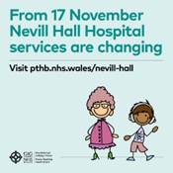 | Nid yw'r mwyafrif o apwyntiadau arferol ar gyfer plant yn cael eu heffeithio gan y #NewidiadauNeuaddNevill.  Bydd @BIPAneurinBevan yn cysylltu â chi os bydd angen iddynt wneud newidiadau i ofal eich plentyn
Emergency care | By understanding the #NevillHallChanges, we can make sure everyone receives the best possible care in the right place at the right time🏥. | 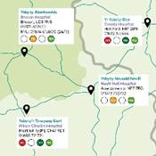 | Trwy ddeall #NewidiadauNeuaddNevill, gallwn sicrhau bod pawb yn derbyn y gofal gorau posibl yn y lle iawn ar yr amser iawn🏥.
Emergency care | From the 17 November, Nevill Hall will no longer offer a consultant-led A&E service.  To find your nearest A&E please look out for your information booklet delivered to your door this week or view the online map on pthb.nhs.wales/nevill-hall. | 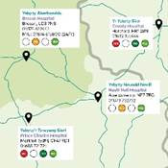 | O'r 17 Tachwedd, ni fydd Neuadd Nevill bellach yn cynnig gwasanaeth damweiniau ac achosion brys dan arweiniad ymgynghorydd.  I ddod o hyd i'ch Adran Damweiniau ac Achosion Brys agosaf cadwch lygad am eich llyfryn gwybodaeth a ddanfonwyd at eich drws yr wythnos hon neu edrychwch ar y map ar-lein fan hyn biap.gig.cymru/neuadd-nevill.
Emergency care | Emergency care at Nevill Hall Hospital is changing on 17 November.  Most Powys residents who currently live closest to NHH will be closer to Prince Charles Hospital from 17 November 2020. |  | Mae gofal brys yn Ysbyty Neuadd Nevill yn newid ar 17 Tachwedd.  Bydd mwyafrif trigolion Powys sy'n byw agosaf at NHH ar hyn o bryd yn agosach at Ysbyty'r Tywysog Charles o 17 Tachwedd 2020.
Future parents | Talk to your midwife about your birth options. They will help you make the best decisions for you and your baby  For more information, visit: pthb.nhs.wales/nevill-hall.  #NevillHallChanges #ClinicalFutures | Static square:  Birth options for people living in South and Mid Powys are changing from mid November 2020.  [NB Don’t think we have this one yet so use this one  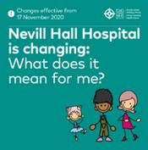 | Siaradwch â'ch bydwraig am eich opsiynau geni. Byddant yn eich helpu i wneud y penderfyniadau gorau i chi a'ch babi  Am ragor o wybodaeth, ewch i: biap.gig.cymru/neuadd-nevill.  #NewidiadauNeuaddHall #DyfodolClinigol
Future parents | #NevillHallChanges its maternity services from mid November.  If you are due to give birth in Nevill Hall Hospital in November, your midwife will help ensure your birth plan meets your needs.  For more information, visit: pthb.nhs.wales/nevill-hall. | Same as above | Mae #NewidiadauNeuaddHall yn newid ei wasanaethau mamolaeth o ganol mis Tachwedd.  Os ydych i fod i roi genedigaeth yn Ysbyty Neuadd Nevill ym mis Tachwedd, bydd eich bydwraig yn helpu i sicrhau bod eich cynllun geni yn diwallu eich anghenion.  Am ragor o wybodaeth, ewch i: biap.gig.cymru/neuadd-nevill.

