
Caereinion Medical Centre, Llanfair Caereinion

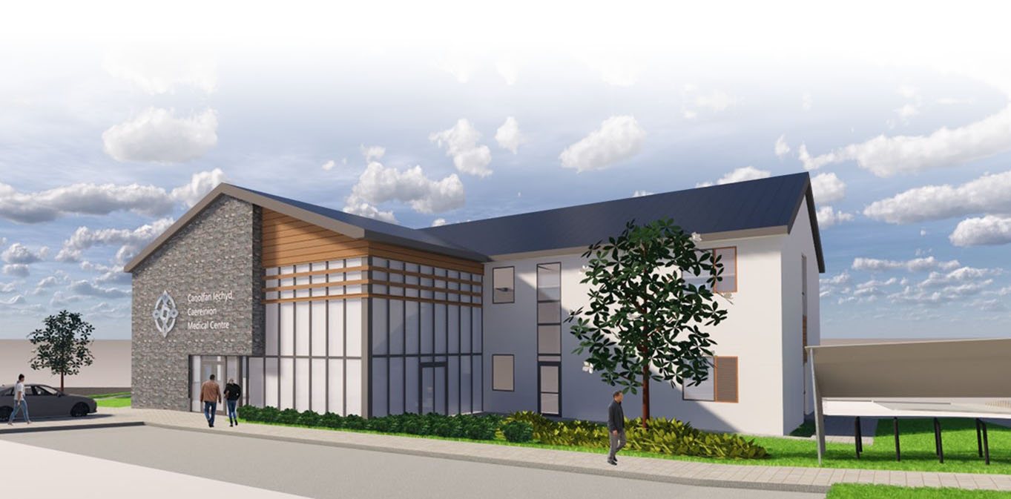
New Surgery Development Update
May 2021

Caereinion Medical Practice and the developer, Assura Plc, would like to thank all the patients and local residents who attended the public consultation event on 10th December 2019. This newsletter aims to give an update on the feedback received, how this has impacted the design, and share the final proposals with you, prior to the commencement of the formal Planning Application process.

Eighty people took part in the event, including local Councillors. The feedback was collated and considered by the LHB, Practice and the design team at an “Achieving Excellence Design Evaluation Toolkit” (AEDET) Workshop in January 2020, facilitated by NHS Wales (see next page for details).
The proposed development scored very highly, achieving 5.87 out of 6. However, due to recent changes in the NHS Model of Care, the workshop highlighted the need for more clinical space. As a result, the proposed building has been enlarged to add an additional four consulting rooms, split equally between the Practice and Health Board. Patient parking has also been increased by an additional 12 parking bays, 3 per Consultation Room.
Last year, in light of Covid-19, NHS Wales also issued some additional design guidance for GP Premises. The design was again reviewed and some small changes made to proposals to introduce features to allow for safe operation during a pandemic situation, including; increased infection prevention measures, social distancing, one way routes, and zoning to allow for isolation both of potentially infectious and extremely clinically vulnerable patients to allow for safe treatment.

Due to Covid, there have been delays in progressing the scheme, however we are happy to share that we are now in a position to start the formal Planning Application process. Full proposals and supporting information will be published shortly for formal public and statutory consultation – details to follow.

The Practice and developer are committed to working with patients and the community and are happy to receive comments and concerns on anything to do with the planning application, and then throughout the construction period and the move to the new facilities. The Practice Manager, Chris Roberts, or Dr Alun Jones-Evans can be contacted via the Practice for anyone with comments or concerns.
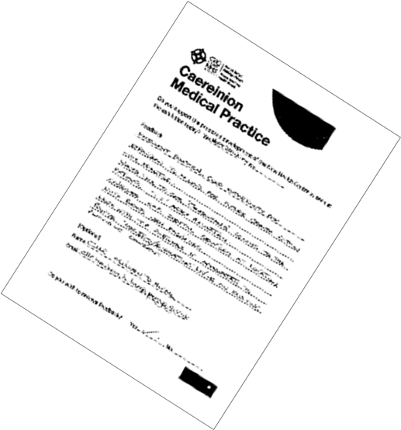
Public Consultation Feedback
Total Attendance (approx.) 80
Number of feedback forms completed 45

Analysis of written feedback

Do you support the proposed development?
- Yes (44)
- No (1)

Summary of Comments: No. of responses
- Impressive Design 11
- Great Building Layout 8
- Good Parking Facilities 10
- Good Location 4
- Great for the community 5
- Will electric car charging points be 1
provided?
- No air ambulance landing pad 4
- Difficulties of travel for elderly people 8
(remote site & no public transport)

Response to queries and issues raised:
- Will electric car charging points be provided?
9 electric car charging points will be provided with the flexibility to increase this number in the future. The development will achieve a high BREEAM sustainability rating, focussing on all aspects of environmental responsibility. Part of that will focus on encouraging green travel, with provision made for upgrading pedestrian routes along Watergate Street to the site, providing secure cycle storage and a layby for a future bus stop, should a route be considered viable in the future.

- There is no landing pad for the Air Ambulance
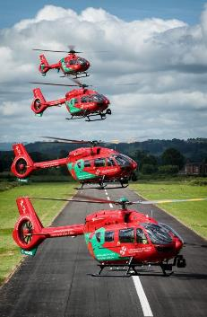
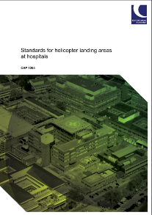
A formal helipad was considered at an early stage of the design. However, it was not possible to provide the space required, free from any obstructions, within the site area available. The approximate area required is shown overlaid in blue over the site. The alternative option, a roof-top helipad was not affordable. However, there is plenty of open space within adjoining fields, which would be suitable for emergency air ambulance landing. Therefore, following liaison with the Health Board, it is proposed that the air ambulance continue to use informal landing sites in surrounding open space, as most appropriate, with a land ambulance transfer from the Medical Centre to the landing location.
The Medical Centre itself has been designed to allow ambulance crews, to access the building and evacuate a patient via stretcher through a discrete side door, to maintain patient privacy and dignity.
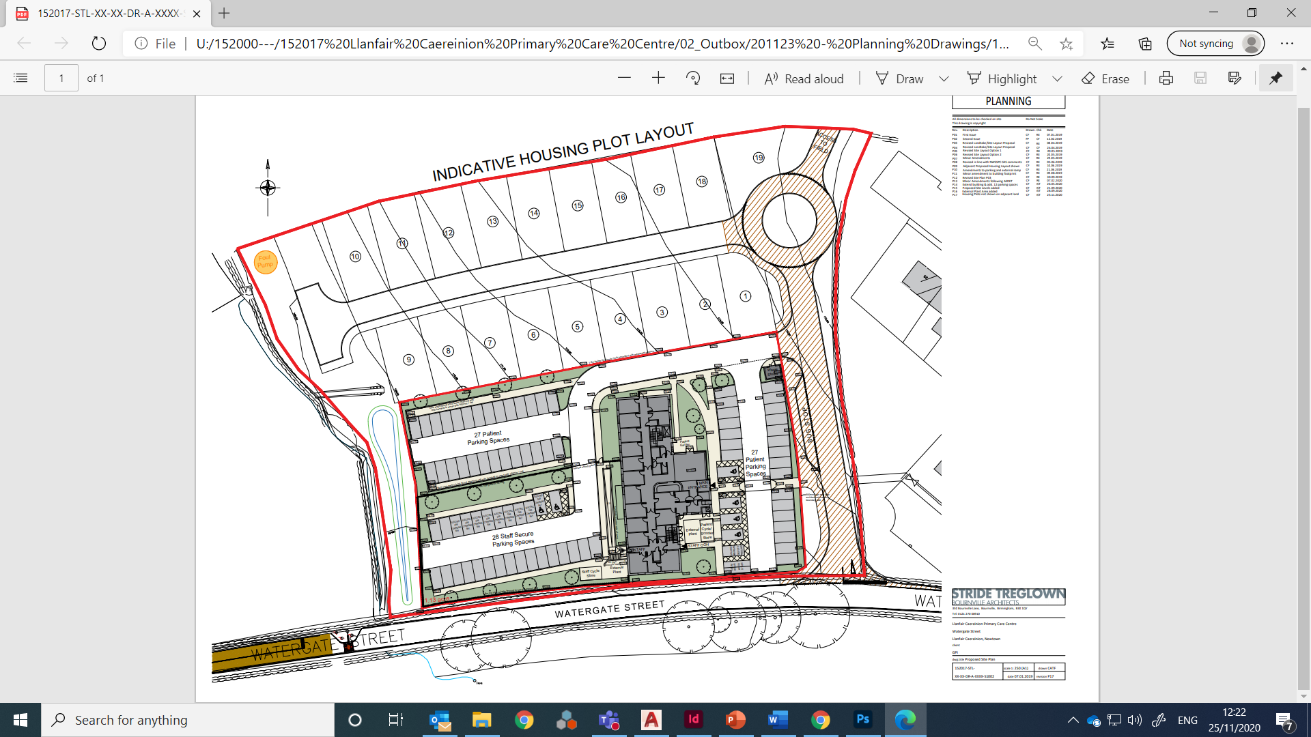

It will be difficult for some people to travel to the Medical Centre, as it is located at the edge of the town and there is no public transport. This is of especially concern to some of the elderly people who do not drive.
All available sites were considered as part of a process of due diligence, but this site was the only that met the requirements (full details of the sites considered and criteria for assessment will be listed within the Design & Access Statement released shortly as part of the Pre-Application Planning Consultation).

We have done what we can to improve access to the site and will be upgrading the footpaths up Watergate Street to give a safe, step-free route. We will provide a bus stop in front of the Centre for future use, if a bus operator can operate a viable service. We will also provide covered cycle and mobility scooter parking next to the main entrance, and drop off points for taxis and social services transport. However we recognise that, for disabled and elderly people in particular, it may still be a challenge to access the centre.

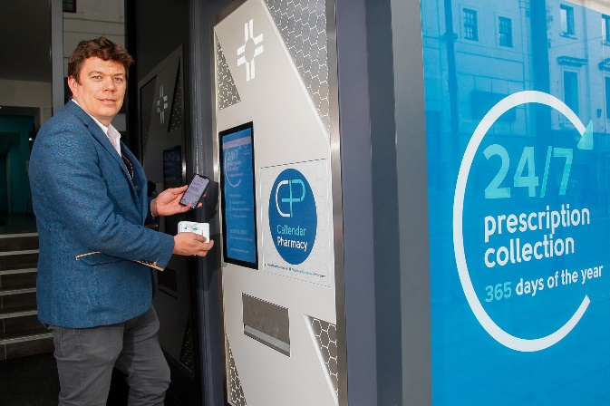
We are considering an automated machine within the external wall of the building (similar to a cash/vending machine), to allow for 24/7 collection of repeat prescriptions. This would allow a relative or friend to pick up your prescription for you at a convenient time for them, if you are unable to get to the Medical Centre yourself.

We will also provide increased access to telephone triage and phone/video consultations, to minimise the need to visit the surgery. For housebound patients, home visits will continue to be offered.

Revised Plans
Please see below the final proposals. The major changes are as follows;
- Additional 4 Consulting Rooms & 12 patient parking bays added (shown in red below)
- Amendments to make the new building Covid-safe with an isolated zone for seeing potentially infectious patients

Site Plan
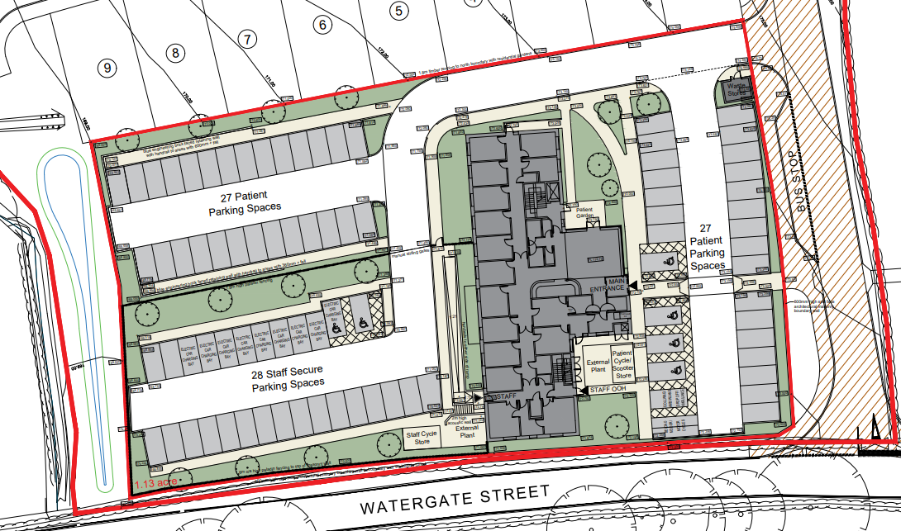

Floor Plans
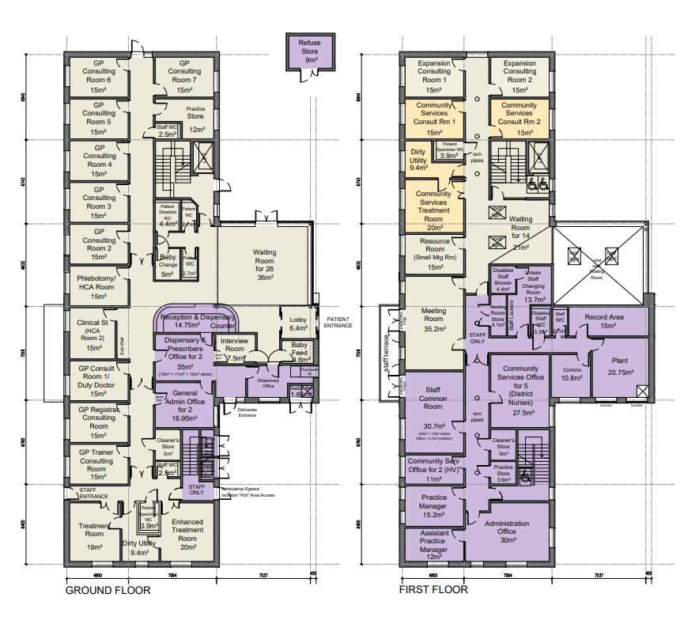
Additional Consulting Rooms
Elevations
