

Occupational Therapy
Learning Disability
North Powys Service

What do we do?
 | Occupational Therapy is about finding ways for people to carry out activities as best they can
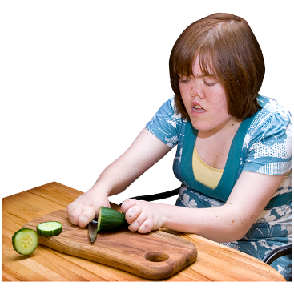 | We advise you and any carers to enable you to do tasks like housework, cooking and taking care of yourself.
 | We assist you to get out and about to do the things you enjoy.
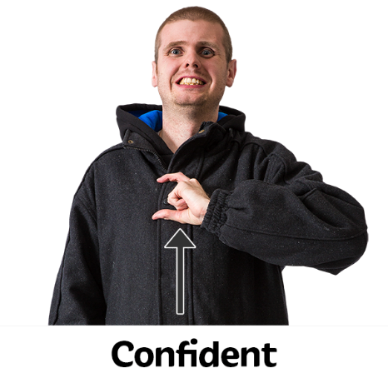 | We aim to build your confidence to do the things you want to do.
 | We advise about sensory needs, such as disliking loud noise or the feel of washing your hair.
How we do it
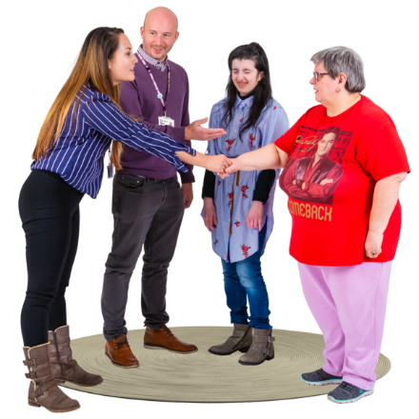 | We can meet you on your own or with family or a carer or a friend.
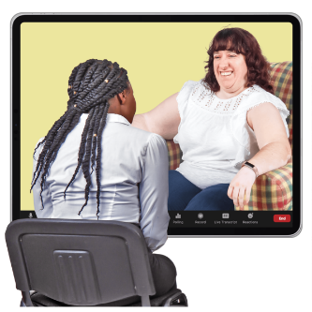 | We can meet you at your home or in a day or education centre. We can use video or telephone calls.
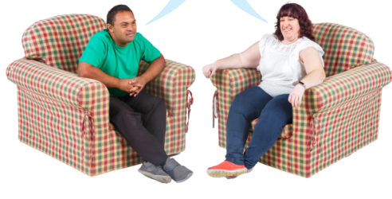 | We will spend time getting to know you, seeing how you manage, and finding out what is important to you.
 | We might also ask people who know you well for information about you.

