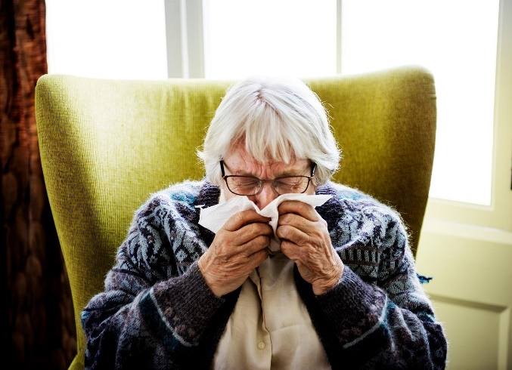
Homely Remedies Toolkit

HOMELY REMEDIES PRINCIPLES
What Is A Homely Remedy?
A homely remedy is a medicinal preparation used to treat minor ailments, which can be bought over the counter and does not require a prescription. These “homely remedy” products are kept in a Care Home to allow access to products which would commonly be available in any household. Homely remedies fall into two legal categories, GSL (General Sales List), which are available widely from supermarkets, pharmacies, and other stores; and P (Pharmacy Only Medicines) which are available only from a pharmacy. They are collectively known as OTC (over the counter) products. Medicines falling into these categories may also be prescribed for service users at the discretion of the resident’s General Practitioner (GP). Homely remedies should not be used for more than 48 hours without consulting the resident’s GP.
Any such medicines which are obtained on prescription must only be administered to the individual specified on the dispensing label. Medicines via a prescription may not be used as a source of stock for the homely remedy supplies.
Residents or relatives may bring in their own “homely remedies” which have been approved by their own GP. These are not for general use in the home and must remain specific to that resident. They should be counted into the home and recorded as for other medication. It must be communicated to the relatives that it is their responsibility for obtaining supplies of these products.
Why Stock Household Remedies?
In a Care Home environment, a resident may develop a minor illness which in their own home would be easily treatable by accessing a local pharmacy for an OTC product. If a resident does not have a suitable remedy on their normal prescription the staff may feel that the only course of action is to call the GP or out of hours service which is not an appropriate use of NHS resources. This may be for something like a headache. By having homely remedies in the care home an immediate need can be met and the GP is only called if the symptoms persist. Homely remedies also allow a person to access medication to relieve the symptoms of a self-limiting condition without delay and without the need to contact the GP just as they would if they were living alone. It is important to recognise that common conditions will get better in time and antibiotics are not always appropriate.

The average span of some common self-limiting conditions is:
- Acute otitis media (Earache) – 4 days
- Acute sore throat/pharyngitis/tonsillitis – 1 week
- Common cold – 1½ week
- Acute rhinosinusitis (blocked nose)– 2½ weeks
- Acute cough/bronchitis – 3 weeks
It is not appropriate to ask a GP to write prescriptions for a “just in case” situation for minor ailments. Prescriptions are written to treat acute need, long term conditions, for anticipatory drugs in terminal care or evidence based preventative medicine.
It is recommended by NICE that a small range of products may be kept in stock in a Care Home for residents for the treatment of minor ailments. Homes who agree to stock such products must develop their own policies. There is a recognised duty of care by care staff to be able to make an appropriate response to symptoms of a minor nature, e.g. toothache or headache, but Carers are clearly limited to making supported decisions. One strategy is to make certain products available to all residents for defined situations. In this circumstance the following would apply:
- Only stock purchased by the Care Home for administration under the ‘Homely Remedies Policy’ may be used
- Only the named preparations listed in the policy may be administered without a prescription
- The decision to administer a homely remedy is supported by adequate training and support
- Products labelled for a particular resident (i.e. for whom a prescription has been issued), brought in by the resident or recommended solely for a particular resident must not be given to another service user as a homely remedy
- All administered doses of homely remedies must be recorded appropriately according to the care home policy
Recommended Homely Remedies
- Paracetamol for Mild to moderate pain and/or fever (Tablets and Suspension)
- Senna for Constipation (Tablets and Suspension)
- Rehydration sachets Fluid and electrolyte loss associated with acute diarrhoea
- Gaviscon Advance® / Peptac® Dyspepsia /Indigestion
- Simple Linctus Dry / irritating cough

Prescriptions for Minor Ailments
The use of homely remedies for the minor ailments named in this toolkit enables appropriately trained care staff to use stocked medication. A GP does NOT need to be contacted to ask for permission to start using a homely remedy.
The named homely remedies may be used for up to 48 hours only to assess the response, after which the symptoms may be resolved, and no further action is needed. If the symptoms have not resolved and the GP wishes to continue the treatment for longer than 48 hours, then a prescription must be written.
Homes are expected to purchase the named medications to be made available for all residents and not request individual prescriptions.
If the person repeatedly needs a homely remedy in the same month for the same symptoms the GP should be contacted to report the frequency, and a review would be needed
Accountability
This toolkit helps to define the actions required by a registered Nurse or Carer to ensure safe and effective administration of household remedies, without a written individual prescription from the patient’s General Practitioner (GP). The purpose of this document is to promote good practice, Nurses are individually and professionally accountable to the Nursing and Midwifery Council (NMC) for their actions and omissions and must act in accordance with the NMC Code of Professional Conduct and Standards for medicine management. The Nurse must recognise the parameters of safe practice and refer the patient to an appropriate medical professional where there is a need. Professional accountability for updating knowledge of homely remedies will lie with the Nurse.
If the decision for administration is taken by a Senior Carer, it must be in accordance with the policy of the Care Home. Senior Carers who do not have nursing qualifications are directly responsible to their manager who must ensure that they are competent to make decisions. Care home staff who give homely remedies to residents should be named in the homely remedies process. They should sign the process to confirm they have skills to administer the homely remedy and acknowledge that they will be accountable for their actions. In all cases the Manager will be responsible for ensuring that appropriate training and support is made available to both Nurses and Carers.

Process
The Manager of the Care Home must write their own procedures for managing homely remedies and stock those products which are listed within the procedure.
NICE Guidance on Managing Medicines in Care Home (2014) states: Care Home providers offering homely remedies for treating minor ailments should consider having a homely remedies process, which includes the following:
- The name of the medicine or product and what it is for
- Which residents should not be given certain medicines or products (e.g. paracetamol should not be given as a homely remedy if a resident is already receiving paracetamol)
- The dose and frequency
- The maximum daily dose
- Where any administration should be recorded, such as on the medicines administration record (MAR)
- How long the medicine or product should be used before referring the resident to the GP

Managing medicines in care homes (nice.org.uk)- Link to NICE guidance
Any products which deviate from this list would need to be approved by an individual GP for the specific patient. It is also recommended that relatives and those with Powers of Attorney are aware that homely remedies may be used in the Care Home and approve this also. The administration of a homely remedy can be either in response to a request from the resident or from a member of care home staff.

Storage of Homely Remedies

- Homely Remedies should be stored in the same location as all other medication, but should be clearly identifiable as a ‘homely remedy’
- All homely remedies MUST be stored in their original packaging together with any information supplied with the product about the medicine use.
- Excessive quantities of homely remedies should not be stored by care homes.
- They should be stored securely in a lockable cupboard or trolley and kept separate to the resident’s prescribed medication.
- Homely remedies should be stored at temperatures below 25^{oC} (unless stated otherwise on the medicine information), Away from damp and strong light. In accordance with the patient information leaflet or any instruction on the packaging.
- If the homely remedy is kept in a resident’s room (e.g. if resident is self-administering or using a cream) then it should be stored in a lockable drawer or cupboard.
• Access to homely remedies should be restricted to staff with medicines management responsibilities.

Record Keeping
The carer/nurse must record the administration of homely remedies according to the care home policy and procedures. The resident’s MAR chart is ideal for recording if it is possible to do so or in the care plan. The entry should be annotated ‘homely remedy’ and should state the following:
- Name of homely remedy given
- Date and time of administration
- Dose given to resident
- Why the homely remedy was given
- Name of carer/nurse who administered the medicine
- Effect of the homely remedy
This information is particularly important, so other members of care staff are aware of when the last dose was given to monitor effectiveness and avoid overdosing. To enable processes to be audited, a running balance of each homely remedy should be kept and checked on a regular basis e.g. monthly. Homely Remedies should be date checked regularly, it is good practice to conduct monthly checks, but at least every six months. The date of opening should be marked on liquid medicines which should be replaced in accordance with manufacturer’s guidance. If creams are stocked then once opened, the date of opening should be recorded, they should only be used for the one resident and should not be shared for infection control reasons. Pump devices are more hygienic.

Disposal
Expired stock should be disposed of in line with the care home’s policy on the disposal of medication.
Adverse Reaction
In the rare event of any adverse reactions, the GP must be informed immediately or 111 for advice.
In the event of a serious life-threatening adverse reaction call 999 (the nurse/carer can carry out emergency treatment only if trained to do so)
The Yellow Card Adverse Drug Reaction Reporting Scheme is a voluntary scheme through which suspected adverse reactions to medicines are notified to the MHRA (Medicines Health Regulatory Authority). It is for the GP to decide, following discussions with the Nurse/Carer, whether to submit a Yellow Card.

