How to look after an Aerochamber Device
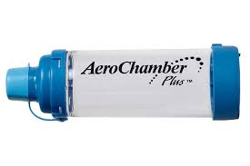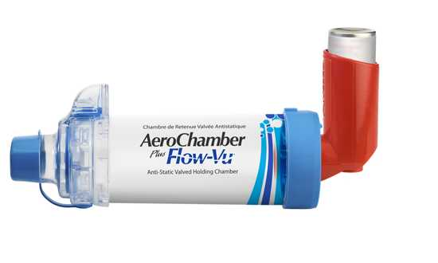

How to look after an Aerochamber spacer device

• Wash the spacer once every month and replace

after one year.

• Remove the rubber end from the spacer.

• Prepare a bowl of room temperature water with some detergent.

Place both rubber end and spacer in the bowl of water.

• Leave to soak for 10 minutes. Rinse well with water.

Leave to drip dry overnight.

• Do not use any towels, tissues, sponges or anything abrasive

to clean or dry your spacer device.

• Do not rub the inside with a cloth or polish as this causes static

build-up which can affect how the device works.

• Aerochamber spacers are not suitable for dishwashers.

• You can clean the mouthpiece with a moist tissue after each

use if needed.

