Good Practice Guidance for Care Homes
Management of Urinary Tract Infection (UTI) for older persons (over 65 years)
For prescribers and all staff responsible for managing residents with UTI’s in care homes
Definition
A UTI is an infection in any part of the urinary system — the kidneys, ureters, bladder and urethra.
Background
UTIs and the Older Person
• UTIs are more common in women than in men with an infection rate increasing with age for both sexes
• UTIs in the older person are often over-diagnosed and over-treated
• Do not dipstick urine in older adults (over 65 years) to diagnose a UTI (unless specifically requested by Prescriber) as up to half of older adults will have bacteria present in bladder/urine without a UTI3
• In older adults (over 65 years of age), diagnosis of UTIs should be based on clinical signs and symptoms (not urine dipstick).4 Signs and Symptoms of a UTI FIRST THINK SEPSIS – always check for any vital signs/symptoms using screening tool such as NICE guidance Overview | Suspected sepsis: recognition, diagnosis and early management | Guidance | NICE or https://sepsistrust.org/
• kidney pain/tenderness in back under ribs
• new/different myalgia (muscle pain), flu-like illness
• nausea/vomiting
• shaking chills (rigors) OR temp over 37.9°C OR 36°C or below
• new onset dysuria (painful or difficult to urinate)
• temperature 1.5°C above patient’s normal twice in the last 12 hours
• new frequency or urgency
• new incontinence
• new or worsening delirium/debility
• new suprapubic pain
• visible haematuria (blood in urine) *If your resident has symptoms listed above then contact the GP
Recommendations
What can I do to help the residents in my care who are at risk of UTIs?
Dehydration can increase the risk of UTIs developing in the elderly. Offer your residents plenty of fluids and keep them hydrated.
What are the common causes of dehydration?
• The elderly have reduced thirst sensation so may not know when they are thirsty • Unable to communicate (cannot say when they are thirsty) • Pre-existing medical conditions e.g. diabetes, stroke. • Dementia – may forget to drink or eat • Cognitive impairment • Medications e.g. diuretics, laxatives • Illness • Fear of incontinence due to drinking • Mobility and dexterity issues – can`t physically go and get a drink • Excessive fluid losses – diarrhoea, sweating, vomiting.
How will I know if someone is dehydrated?
You client may have some of the following signs or symptoms if dehydrated:
- Dry mouth
- Headache
- Dizziness
- Tiredness
- Confusion or not wanting to take part in activities
- Constipation
- Pressure ulcers
- Falls
- Kidney stones
- Low blood pressure
- Medication toxicity
- UTI (urinary tract infection)
- Dark coloured urine
How can I help someone keep hydrated?
Remember, adults need to drink 6-8 large glasses (approx. 1600mls) of fluid each day to keep hydrated!
✓ Identify those with poor fluid intake/ are at risk of dehydration/ those that require assistance with drinking, make sure to monitor and record their fluid intake
✓ Provide ice-pops for the people who may not like drinking
✓ Give water with every meal
✓ As the weather gets warmer, increase the availability of drinking water and encourage patients to drink more
✓ Try serving water (hot or cold) with slices of orange, lime or lemon
✓ Many fruits and vegetables also contain water which can help with maintaining hydration
✓ Asking residents what their favourite drink is or serving it in a favourite cup/mug etc.
✓ Have signs around care homes to encourage people to drink plenty of fluids
✓ Encourage sips of fluid little and often in people with poor mouth control
✓ Serve water fresh and chilled
✓ Offer water and fluids throughout the day – at mealtimes and between meals- some people prefer to drink “little and often”. Ensure glasses are filled up!
✓ Ensure drinking water is visible and easily accessible

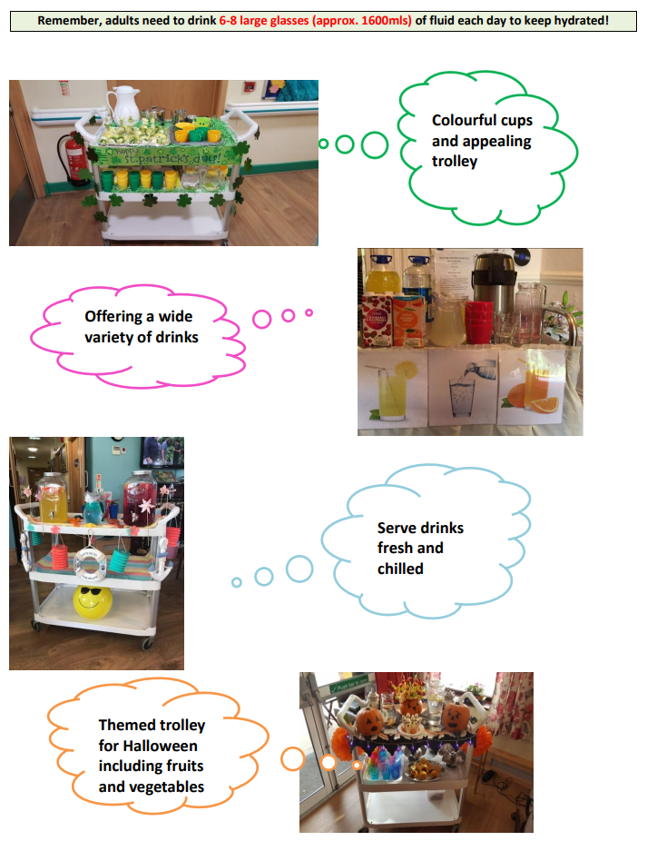
Hydration stations

