

Reducing medicines waste in care homes

Does this picture look familiar? This is just one example of a month’s worth of medication waste from some of the residents within a Powys care home.

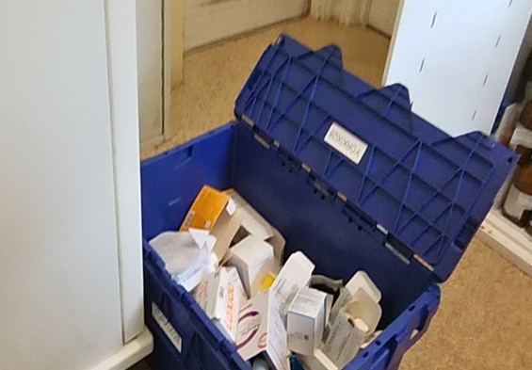
Are you generating medication waste like this in your care home? What can you do to reduce medication waste? Do you know how much this waste costs the NHS? On a recent visit , we calculated a month’s returns waste to the value of £735.
Approximately £22,500 is wasted each year in care homes in Powys. This is just a small part of the bigger picture. Across the UK, medication waste costs the NHS approximately £300 million each year, with a significant portion coming from care homes. This money could be better utilised in other areas of patient care if waste were minimised.
By taking proactive steps to reduce medication waste, care homes can contribute to significant cost savings for the NHS while also improving the quality of care for their residents.

General advice to reduce waste when ordering medicines

- The care home should retain responsibility for all medication orders
- When ordering medicines, only request items that are needed after checking current stock
- Ensure any medicines that have been discontinued are not ordered – check medication policy locally for procedure if unsure
- Check that all prescriptions received from the surgery match the prescription requests- Cross off any items that were not ordered before sending prescriptions to the pharmacy contractor. Inform the GP surgery of any items crossed off so they can update their records.
- Roll over ALL unused medications to the next monthly cycle, including repeat items – do not discard anything which can be used.
- Avoid keeping excess amounts of When Required medications in stock-see below an example of excess when required stock from a recent visit.
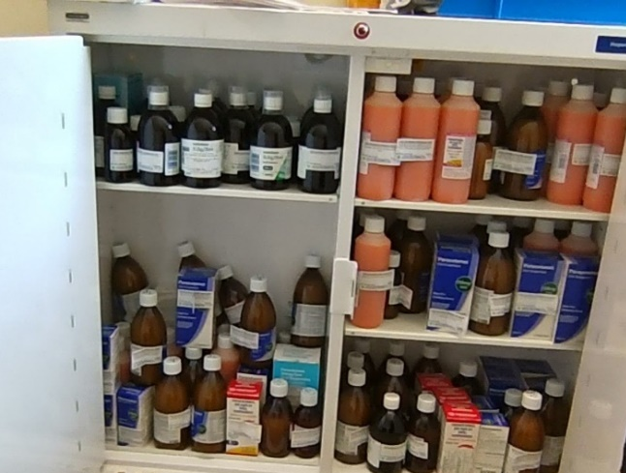
- If you have excess amounts supplied each month, as the GP to reduce the monthly amount.
- Order an interim quantity to align medications, rather than full boxes.
- If you are a nursing home, check dressings stock- only order what you need.
- Keep an eye on inhalers, don’t just tick every month.
- Check expiry dates on medications, use the oldest first to the risk of out-of-date medications.
- Ensure opening dates are added to external items such as creams and oral liquids.

