All Wales Patient Self-Testing Blood Glucose Meters Guidance

Background

All Health Boards in NHS Wales, in conjunction with NWSSP Procurement Services have completed a procurement process to rationalise the choice of blood glucose meters for patients with diabetes.

Suppliers on the national drug tariff for these items were invited to participate and were subsequently evaluated on their technical and commercial capabilities.

This guidance is in place until at least 31st July 2026, at which point it will be reviewed.

Insulin Pumps

Insulin pumps are not included in this Guidance, please seek advice from specialist teams regarding these.

Continuous and Flash Glucose Monitoring

Continuous and Flash Glucose Monitoring are not included in this Guidance, please seek advice from specialist teams regarding these.

Specialist Categories

Please seek advice from specialist teams for Categories 3 and 4 if further options are required.

Category and meter information is overleaf.

1. Glucose Meters

Meter | Wavesense Jazz Meter  (Agamatrix Europe)  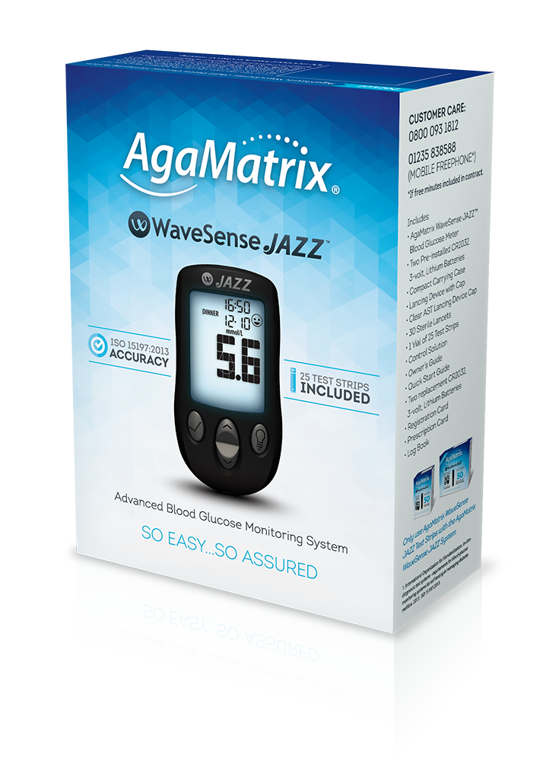 | Contour Plus Blue Meter  (Ascensia Diabetes Care)  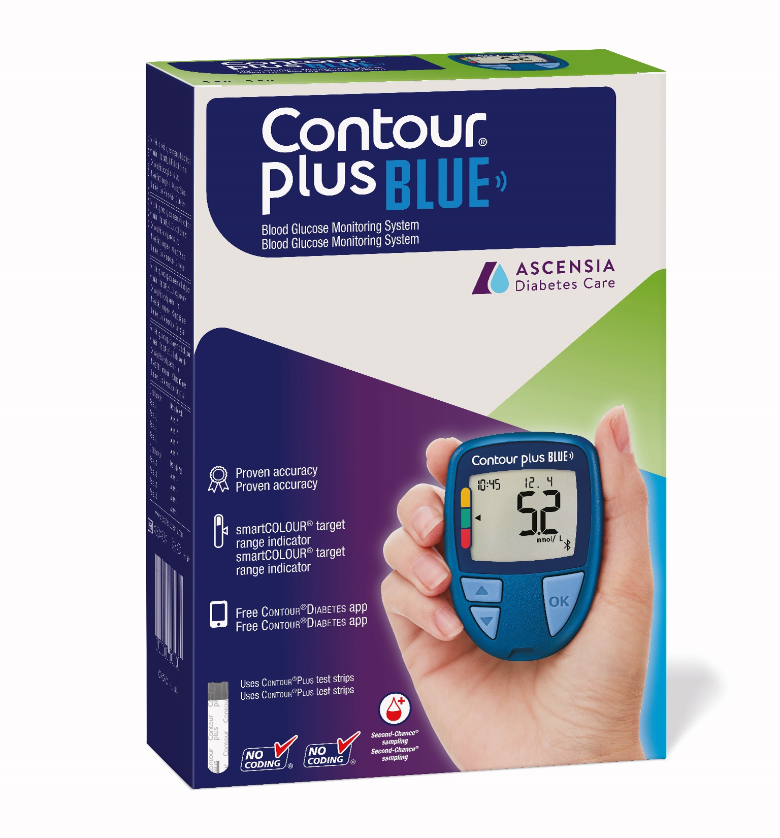 | Accu-Chek Instant Meter  (Roche Diabetes Care)  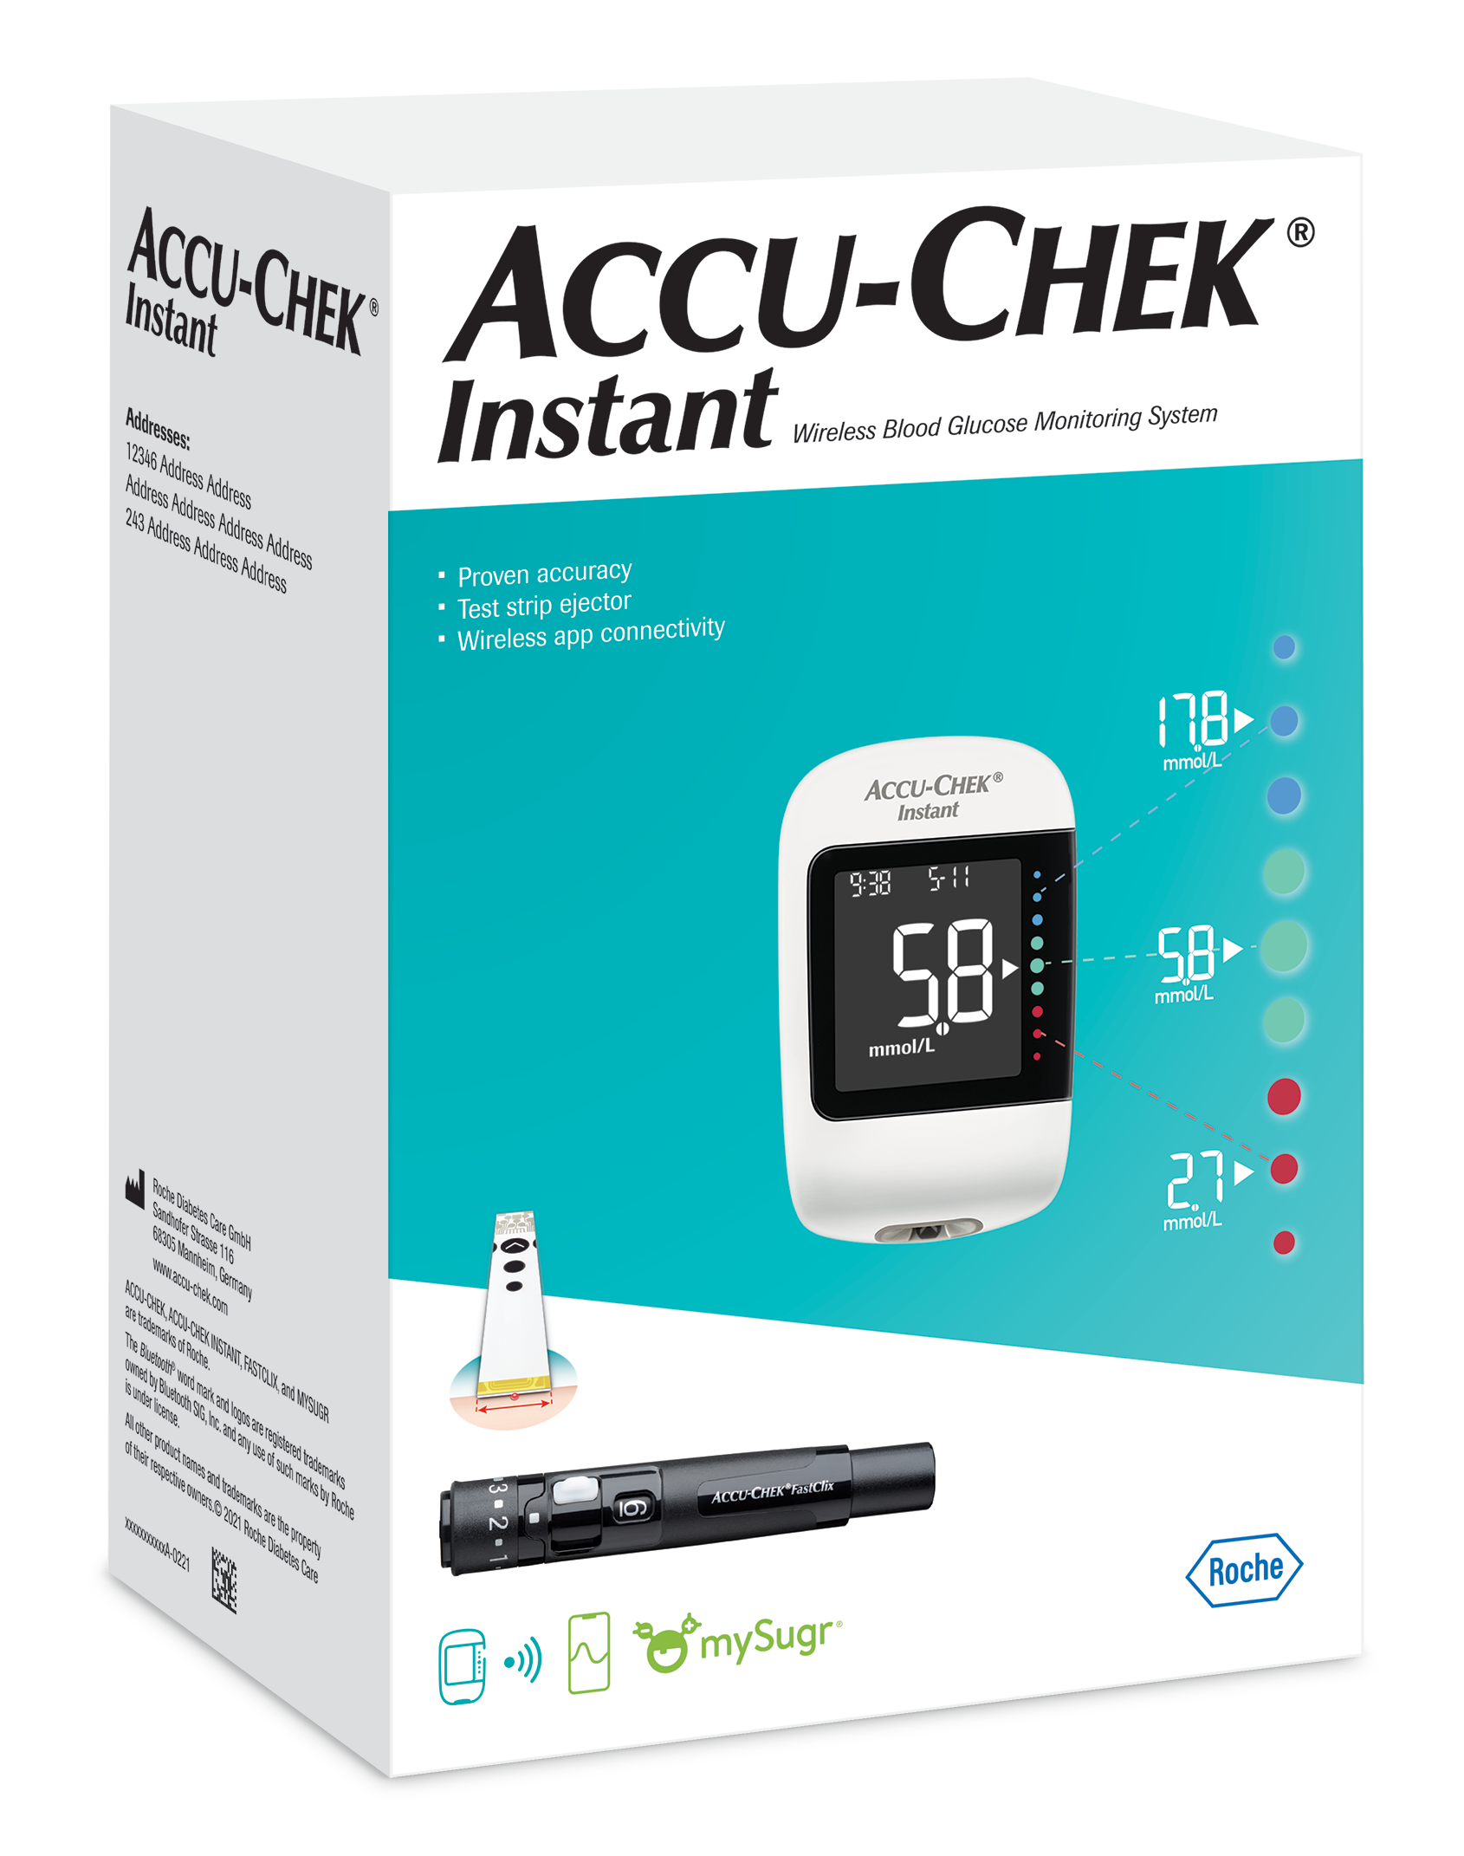
Strips | Wavesense Jazz Test Strips  £8.74 for pack of 50  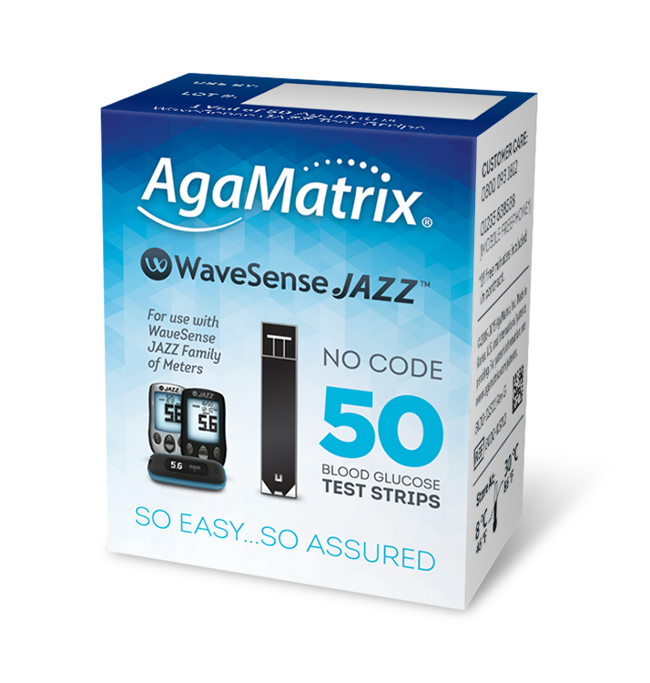 | Contour Plus Blue Test Strips  £5.95 for pack of 50  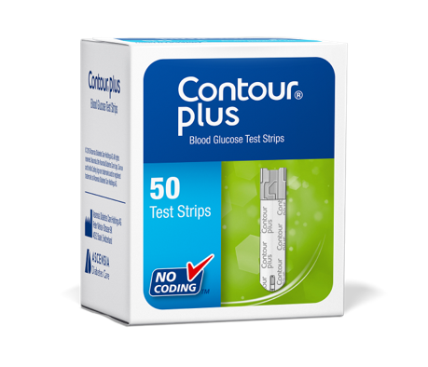 | Accu-Chek Instant Blood Glucose Test Strips  £5.95 for a pack of 50  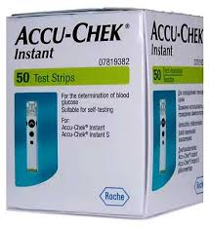
Lancets | UltraThin Lancets  £5.43 for pack of 200  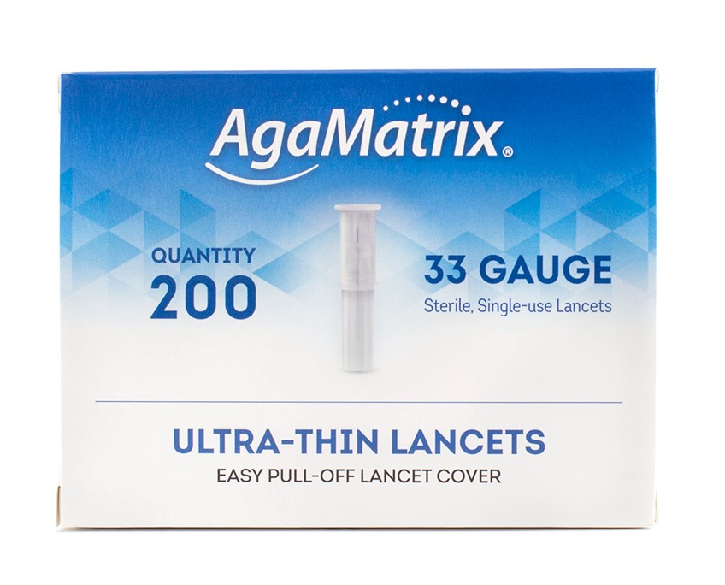 | Microlet Lancets  £2.99 for pack of 100  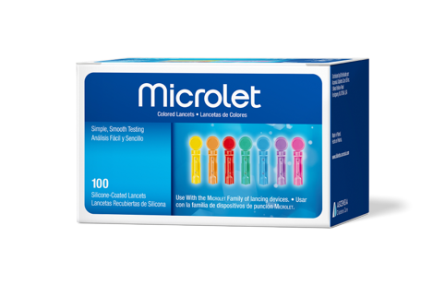 | Accu-Chek Fastclix Lancets  £5.90 for a pack of 204  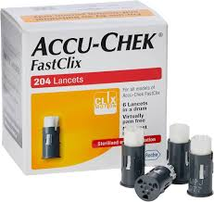

2. Glucose and Ketone Meters

Meter | GlucoFix Tech Meter  (A Menarini Diagnostics)  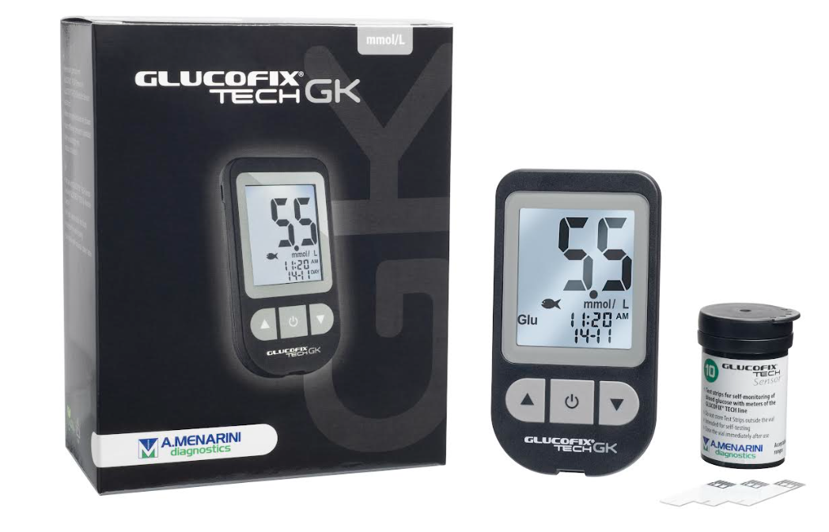 | 4Sure Smart Duo Meter  (Nipro Diagnostics)  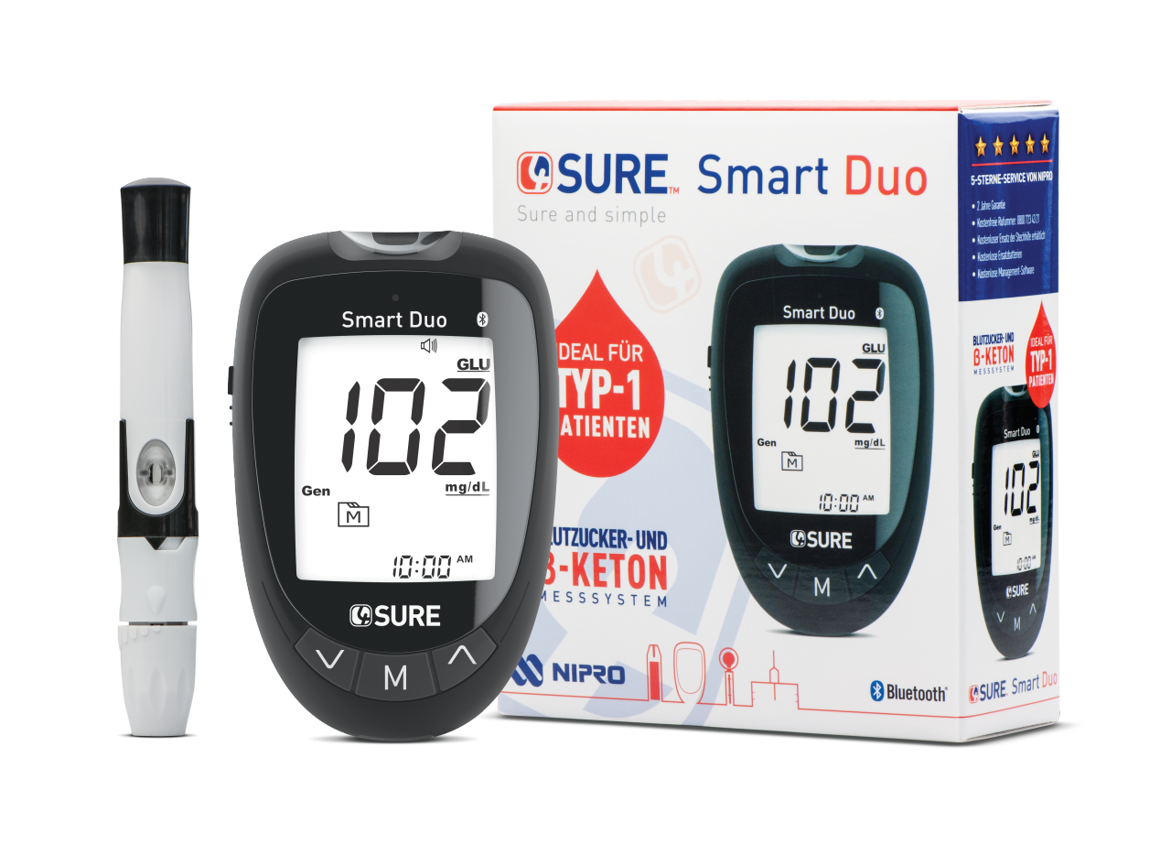
Glucose Strips | GlucoFix Tech Glucose Sensor Test Strips  £5.95 for pack of 50  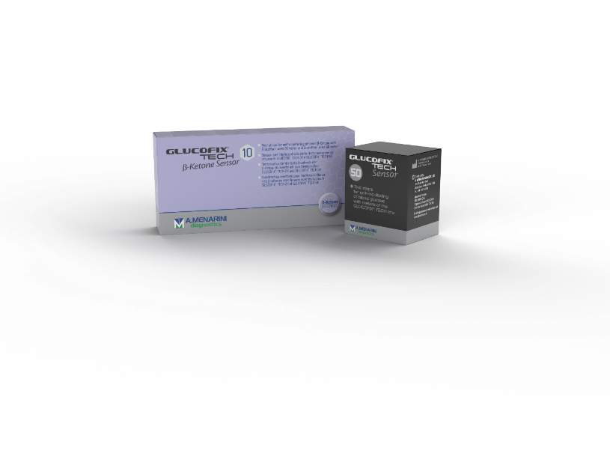 | 4Sure Glucose Strips  £8.99 for pack of 50  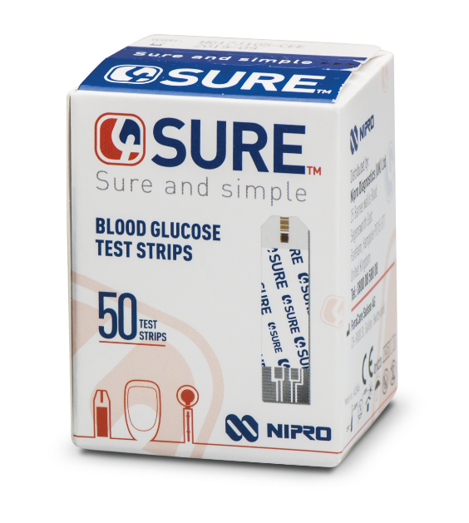
Ketone Strips | GlucoFix Tech Ketone Sensor Test Strips  £9.95 for pack of 10 | 4Sure B-ketone Test Strips  £9.92 for pack of 10  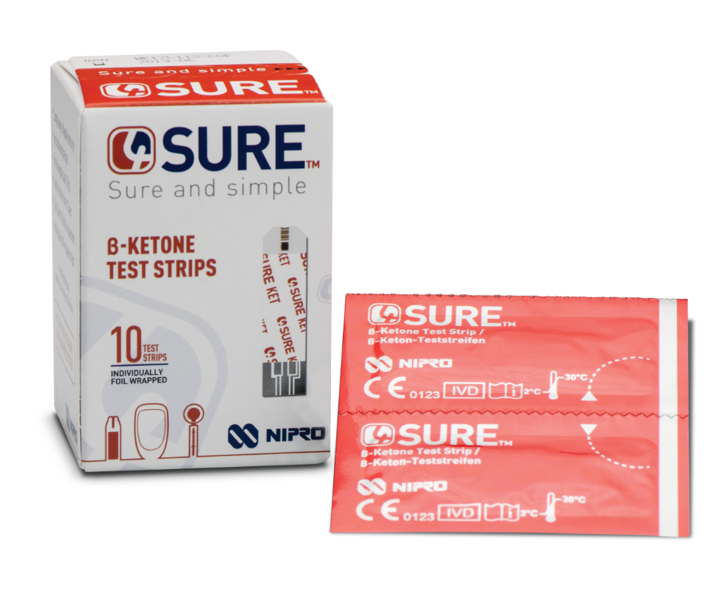
Lancets | 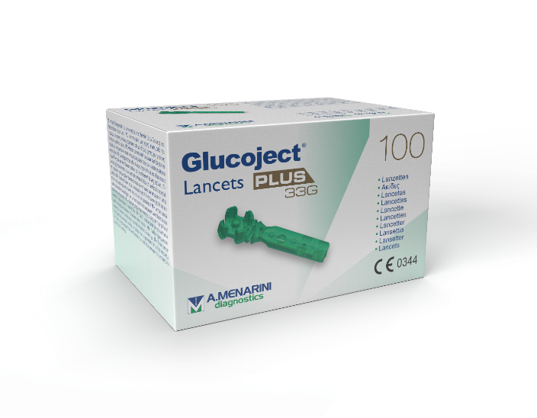  GlucoJect Lancets PLUS  £3.77 for pack of 100 | 4Sure Lancets  £2.90 for 100  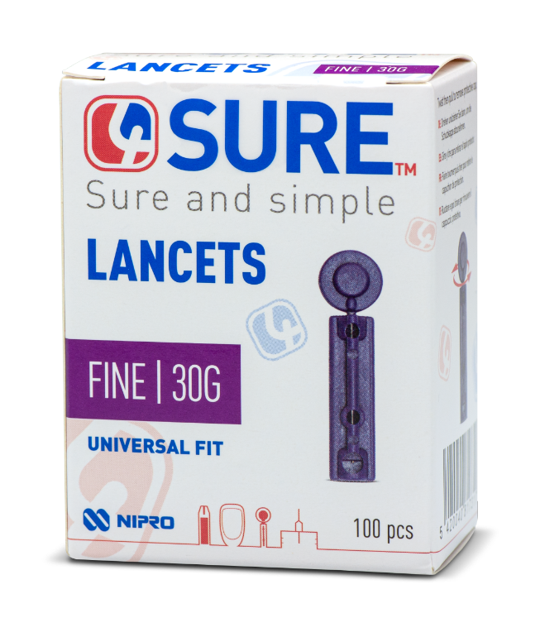

3. Meter Specific for Patients with Dexterity Issues

Meter | Contour Plus Blue Meter  (Ascensia Diabetes Care)
Strips | Contour Plus Test Strips  £5.95 for pack of 50
Lancets | Microlet Lancets  £2.99 for pack of 100

4. Meter Specific for Patients with Gestational Diabetes

Meter | Contour Plus Blue Meter  (Ascensia Diabetes Care)
Strips | Contour Plus Test Strips  £5.95 for pack of 50
Lancets | Microlet Lancets  £2.99 for pack of 100

Supplier Contact Details

Supplier | Name | HBs Covered: | Phone | Email
A Menarini Diagnostics | Ben Smith | BCUHB | 07776227501 | bsmith@menarinidiag.com
A Menarini Diagnostics | Carol Linge | ABUHB, CTMUHB, CAVUHB, HDUHB, PTHB & SBUHB | 07885556458 | clinge@menarinidiag.com
A Menarini Diagnostics | Sam Maylott | All | 07775585618 | smaylott@menarinidiag.com
Agamatrix Europe | Leanne Davies | BCUHB | 07741573574 | ldavies@agamatrix.com
Agamatrix Europe | Claudia Ovens | ABUHB & CAVUHB | 07717306403 | covens@agamatrix.com
Agamatrix Europe | Ian Williams | CTUHB, HDUHB, PTHB & SBUHB | 07825614304 | iwilliams@agamatrix.com
Ascensia Diabetes Care | Christine Phennah | All | 07836567102 | chris.phennah@ascensia.com
Nipro Diagnostics | General Office | All | 02380604300 | sales.support@nipro-group.com
Nipro Diagnostics | Lily Watson | All | 07341657725 | lily.watson@nipro-group.com
Roche Diabetes Care | Liz Grace | All | 07525766455 | liz.grace@roche.com









