Helapet Vaccine Porters: Visual with Instructions v2.0
Wipe vaccine porter inside and out with a Clinell wipe prior to use.
Cool packs used must be taken from the refrigerator and must have been cooled for 24 hours prior to use.
For easy identification, all porters must have a number assigned to them and the name of the department to which they belong. This must be displayed in the front plastic pocket and must be clearly visible. Additionally, all vaccine porters must display a label in bold red type stating “contains temperature sensitive medicines / vaccines” which should also be clearly visible. Helapet vaccine porters should be lined with a material such as bubble wrap to protect the product from contact with the cool packs.

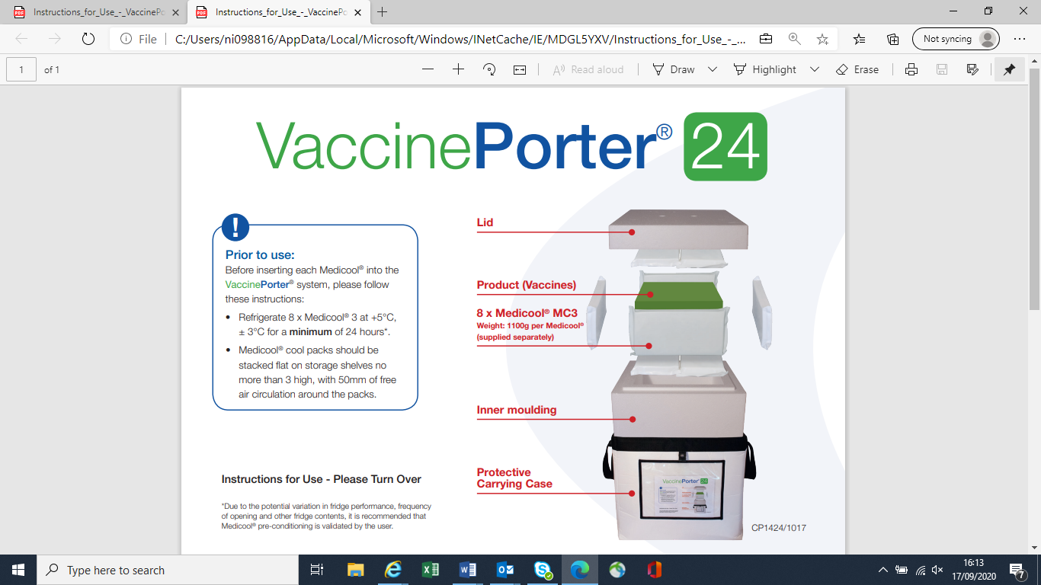
Large Vaccine Porter
- 8 large cool packs in total

Instructions for Use

Pack and seal the vaccine porter swiftly, as follows:

- 1. Place 2 x large cool packs on the base of the system.
- 2. Place the product to be transported in the centre of the vaccine porter.
- 3. Place 1 x large cool pack on each side of the system, surrounding the product load.
- 4. Place 2 x large cool packs on top of the product.
- 5. Close the lid and ensure it is sealed by closing the outer carrying case immediately.
- 6. Only open the vaccine porter if necessary and remember to re-seal as soon as possible.

Medium Vaccine Porter
- 14 small cool packs in total
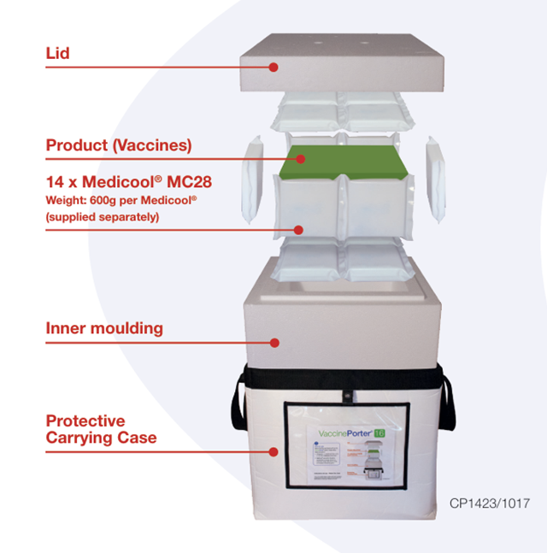
Instructions for Use

Pack and seal the vaccine porter swiftly, as follows:

1. Place 4 x small cool packs on the base of the system.
2. Place the product to be transported in the centre of the vaccine porter.
3. Place 2 x small cool packs on each side of the system, and one on each end, surrounding the product load.
4. Place 4 x small cool packs on top of the product.
5. Close the lid and ensure it is sealed by closing the outer carrying case immediately.
6. Only open the vaccine porter if necessary and remember to re-seal as soon
as possible.
Small Vaccine Porter
- 6 small cool packs in total
Instructions for Use
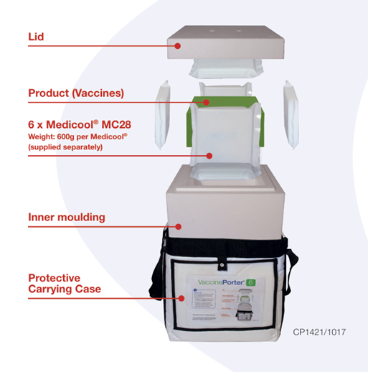
Pack and seal the vaccine porter swiftly, as follows:

1. Place 1 x small cool pack on the base of the system.
2. Place the product to be transported in the centre of the vaccine porter.
3. Place 1 x small cool pack on each side of the system, surrounding the product load.
4. Place 1 x small cool pack on top of the product.
5. Close the lid and ensure it is sealed by closing the outer carrying case immediately.
6. Only open the vaccine porter if necessary and remember to re-seal as soon
as possible.

Nikki Mathers 23/12/2021. Reviewed 11/05/2026 – Nikki Mathers

